1. Created a microservice on AWS Lambda called “lambda-microservice”.

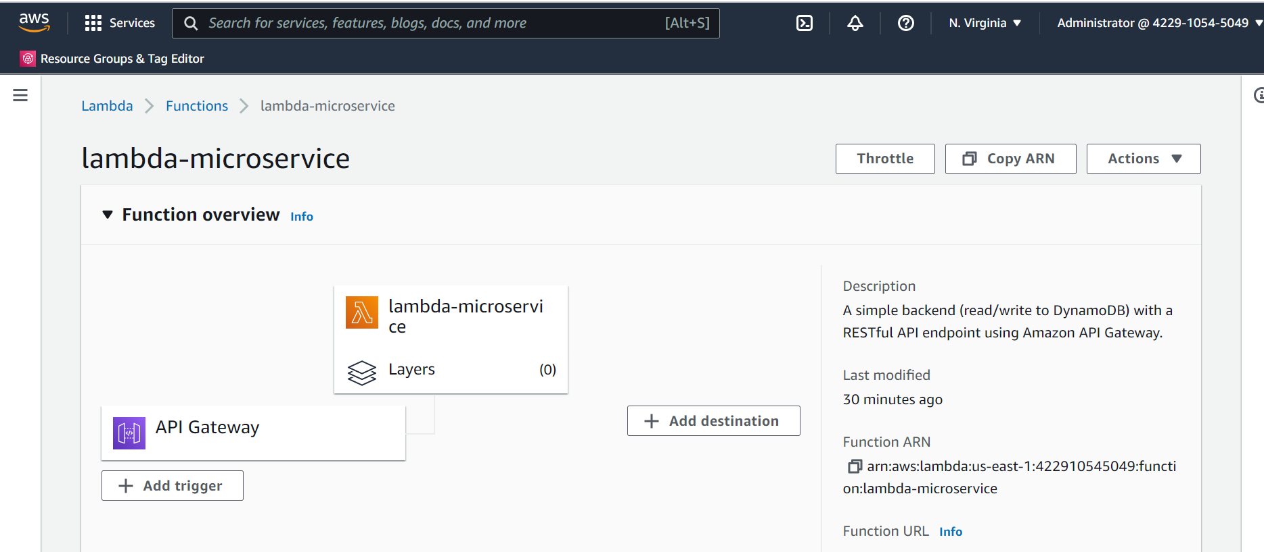

1. The API gateway used here is based on HTTP API as follows:

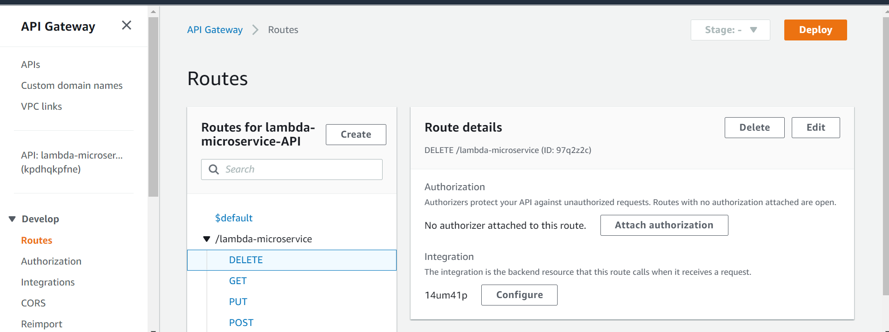

1. The Http methods used are GET, POST, PUT and DELETE. We scan the data, add data, update a data or delete a data in DynamoDB table using these methods.
2. The lambda code is available is containing folder with name: “index.js”
3. DynamoDB table used is “MyTable”

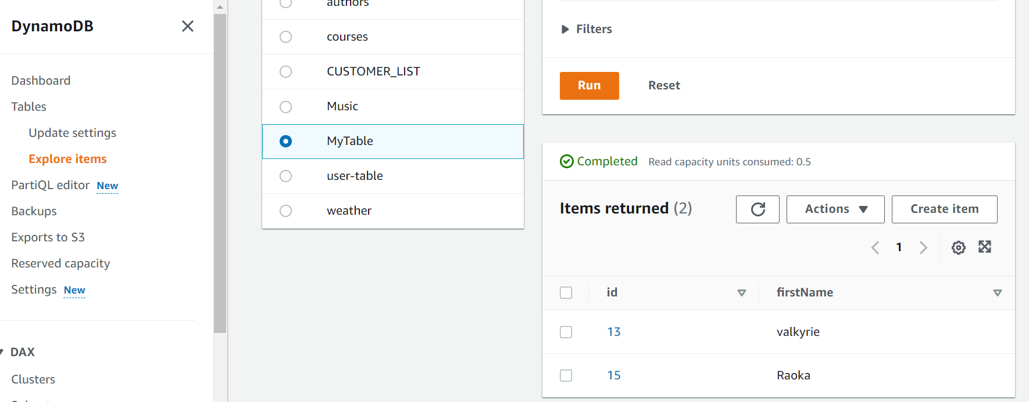

1. GET (or scan the table) operation:

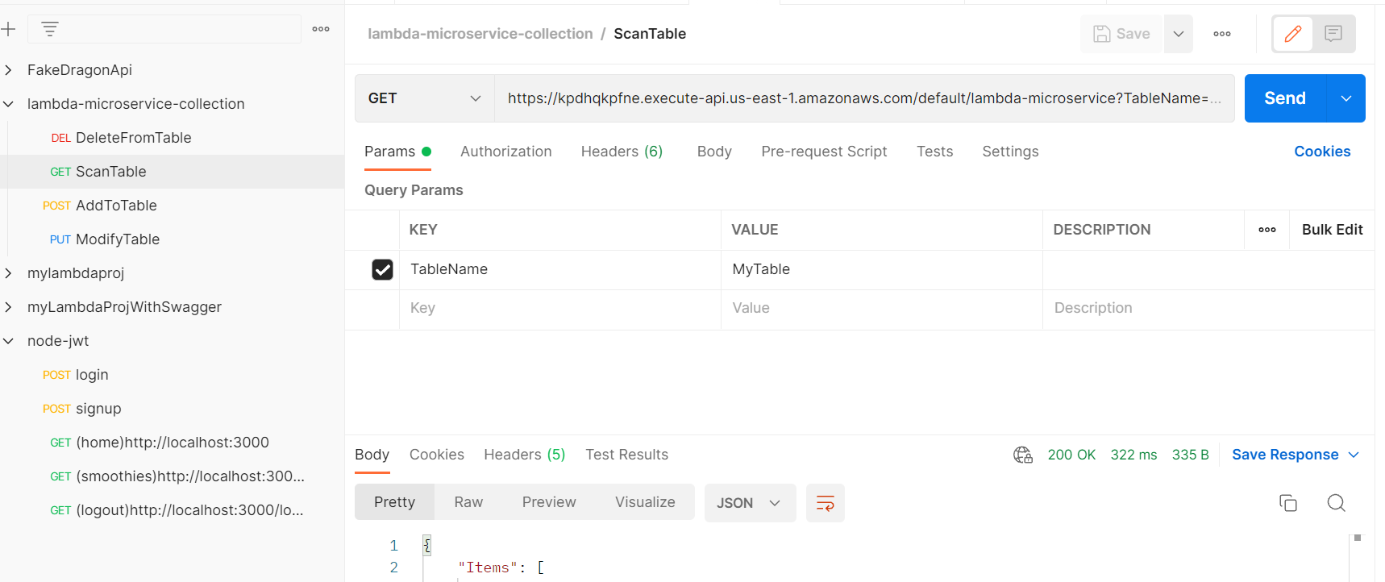

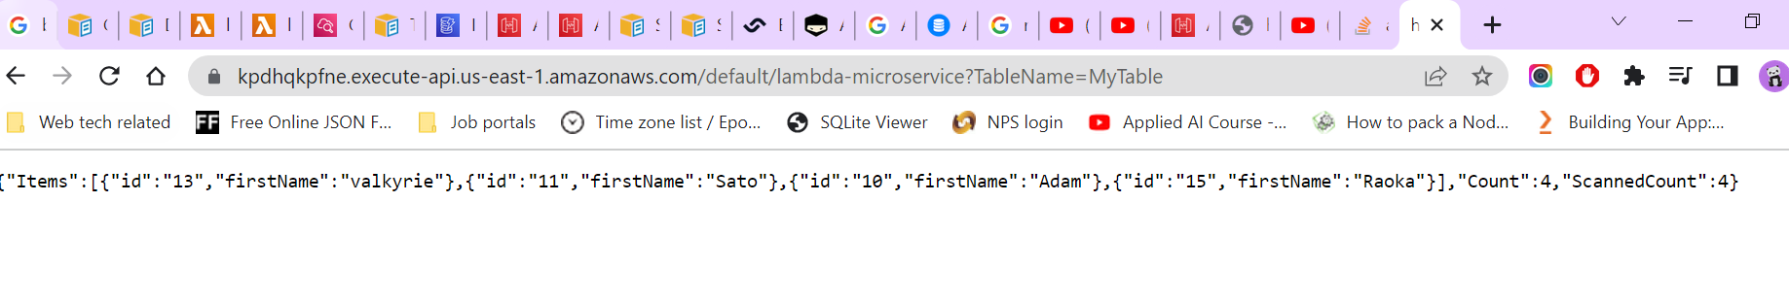

URL to check: <https://kpdhqkpfne.execute-api.us-east-1.amazonaws.com/default/lambda-microservice?TableName=MyTable>

1. POST (add data to DB) operation:

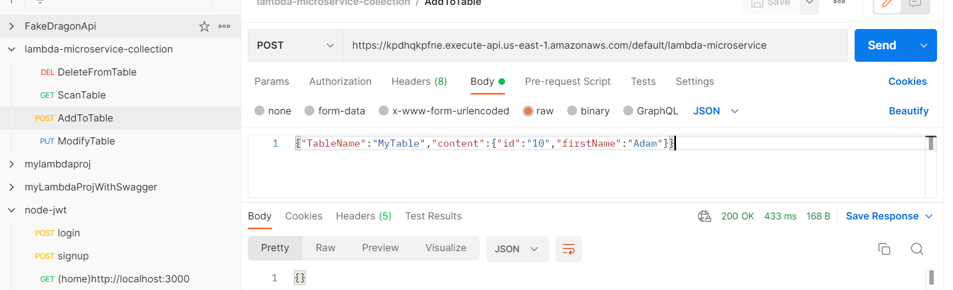

1. PUT (update a data) operation:

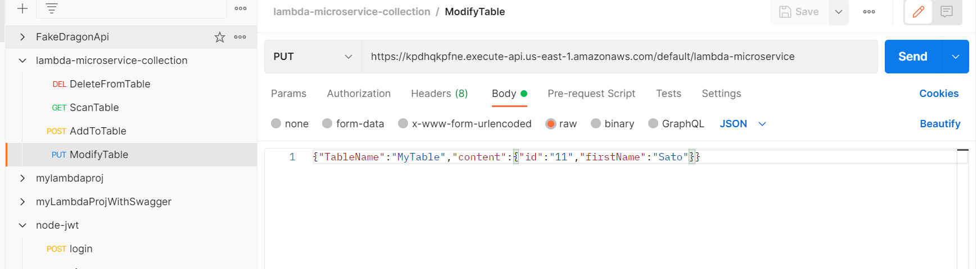

1. DELETE (delete a data) operation:

